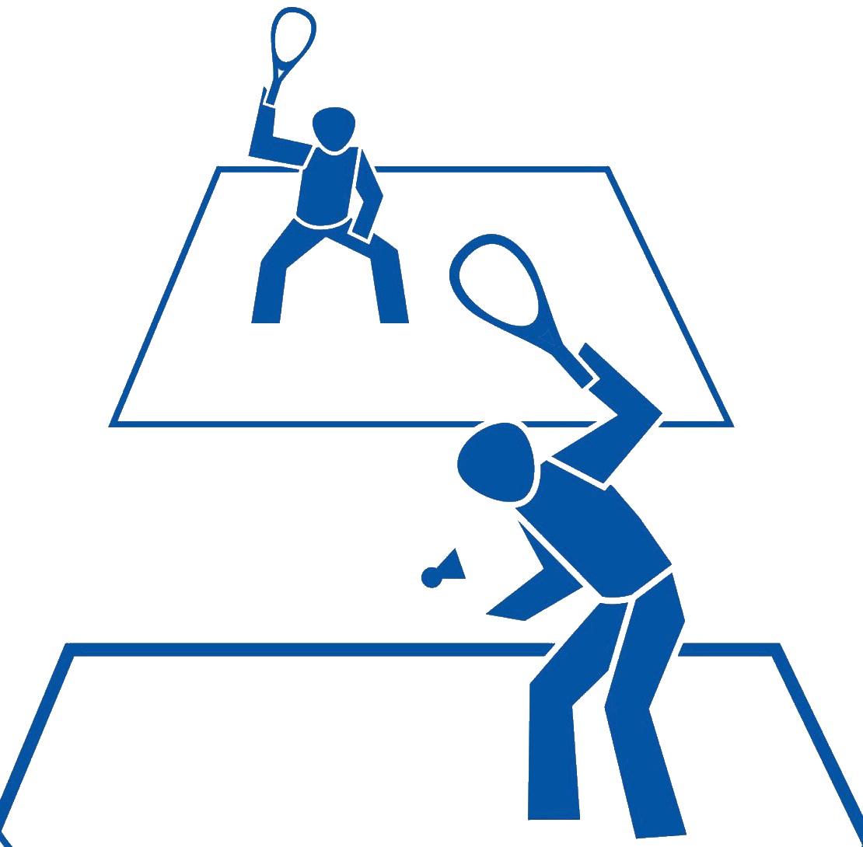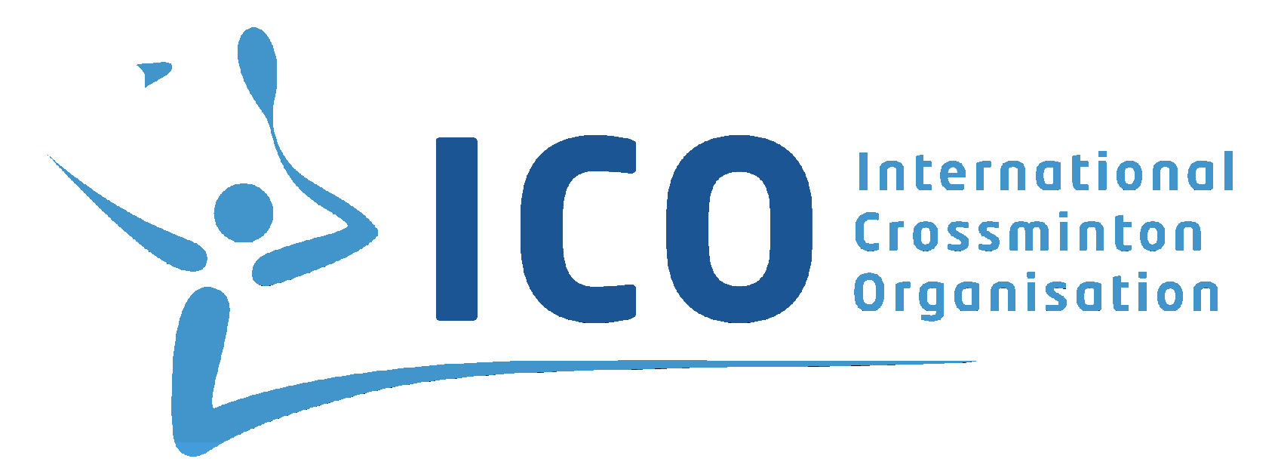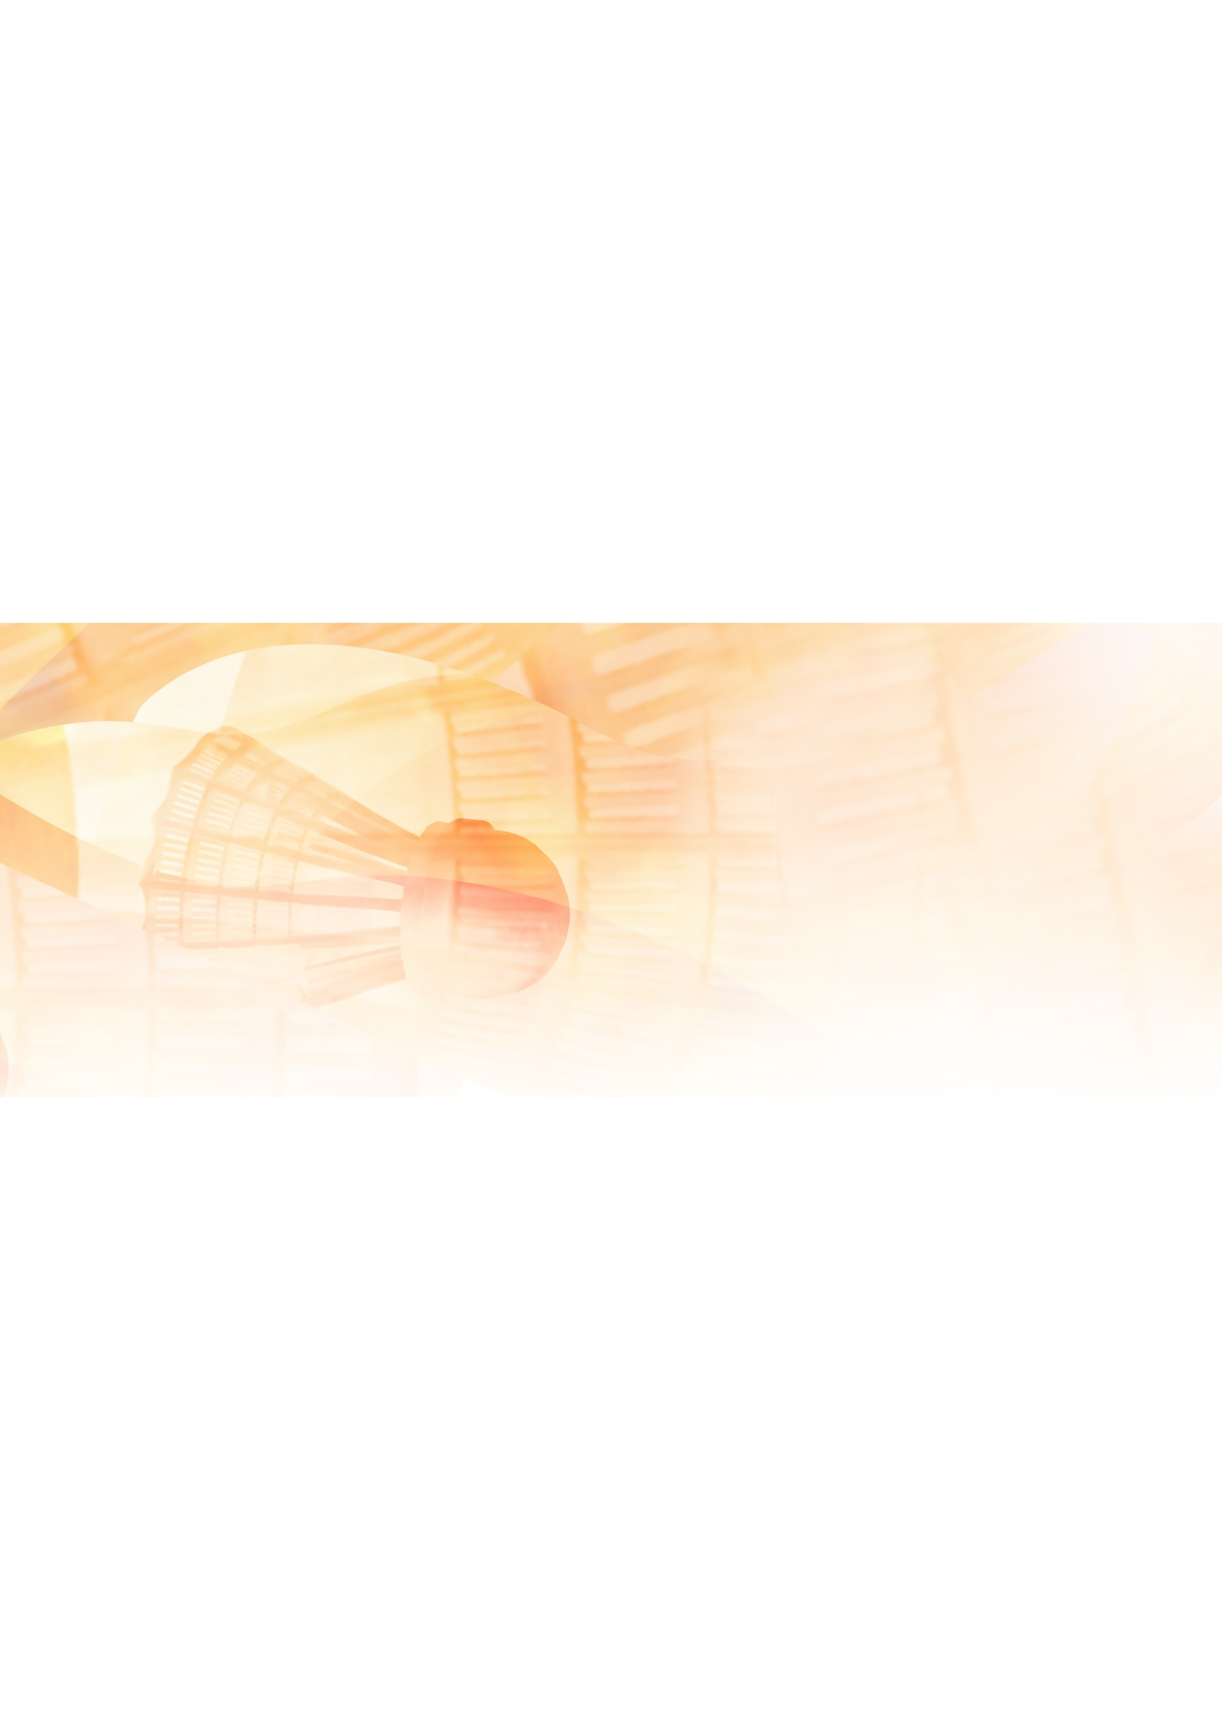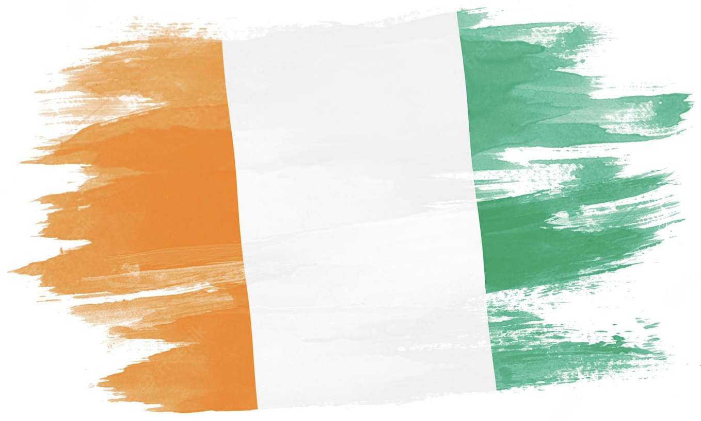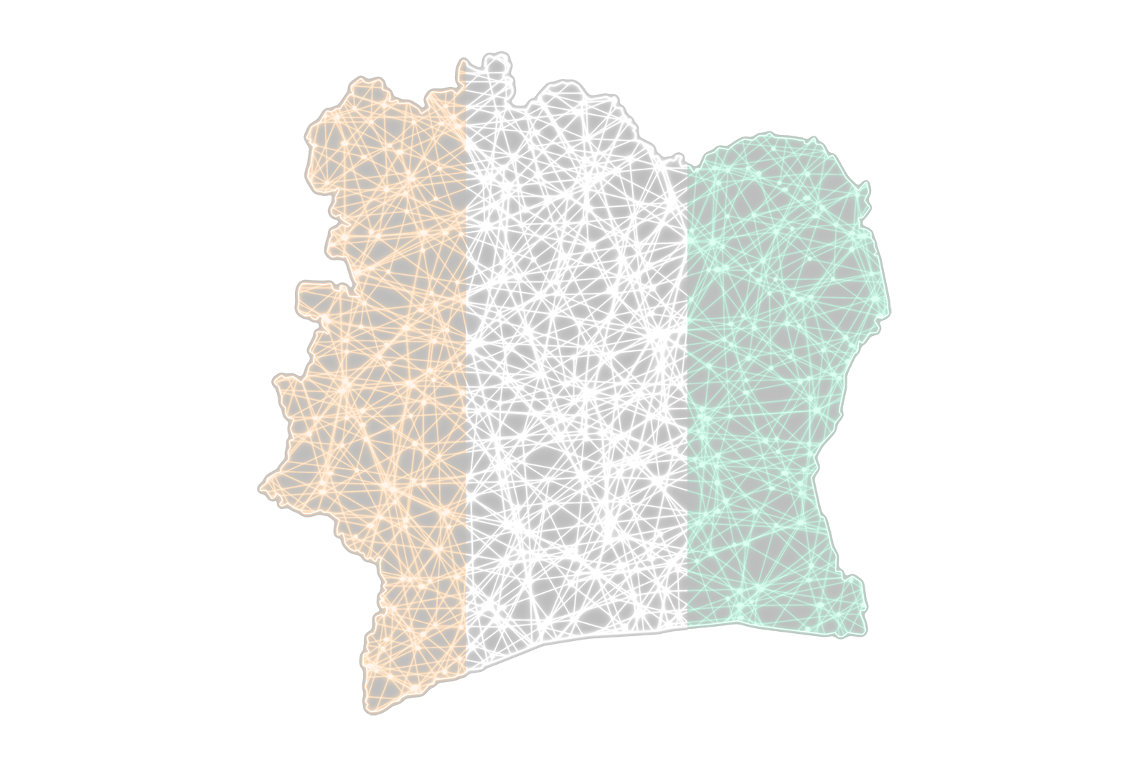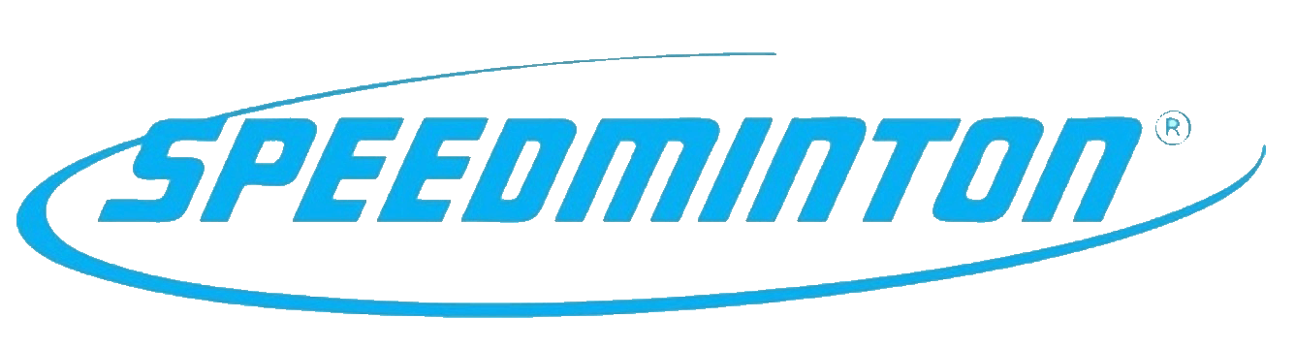­

*Champion*

*Open division*

*4th December 2022 Yamoussoukro, Ivory Coast*

*Signature Signature*

*Henri Joel Kouame, President Stephane Yao Kassi, President*

*Yamoussoukro Crossminton Club Federation Ivoriene de Crossminton*

**ICO CROSSMINTON**

**IVORY COAST OPEN 2022**

**powered by Speedminton®**

***international series tournament – 250 points***